Adrian Cuyugan Stat 266 Rank Test
The data set consists of tabulated MTTR (mean time to resolve) tickets on a daily basis where weekends have been omitted. Only the MTTR column is used for calculating/testing ranks. Test of rank is used because it is more robust for time-series data. The chosen level of significance for both tests is 0.05.
 |  |  |  |  | n = 10 |  |  |  | n > 10
Date | Tickets | MTTR |  | Rank | Diff | NM |  | Rank | Diff | NM
3/2/2015 | 3218 | 9.4 |  | 3 |  | 4 |  | 3 |  | 4
3/3/2015 | 2966 | 8.7 |  | 1 | -2 | 16 |  | 1 | -2 | 16
3/4/2015 | 2759 | 10.2 |  | 5 | 4 | 12.25 |  | 5 | 4 | 20.25
3/5/2015 | 2611 | 12.6 |  | 8.5 | 3.5 | 0 |  | 9.5 | 4.5 | 0
3/6/2015 | 2355 | 12.6 |  | 8.5 | 0 | 20.25 |  | 9.5 | 0 | 30.25
3/9/2015 | 2976 | 9.7 |  | 4 | -4.5 | 4 |  | 4 | -5.5 | 4
3/10/2015 | 2727 | 9.2 |  | 2 | -2 | 16 |  | 2 | -2 | 16
3/11/2015 | 2759 | 11.2 |  | 6 | 4 | 1 |  | 6 | 4 | 4
3/12/2015 | 2811 | 11.8 |  | 7 | 1 | 9 |  | 8 | 2 | 9
3/13/2015 | 2144 | 13.3 |  | 10 | 3 | - |  | 11 | 3 | 16
3/16/2015 | 2937 | 11.3 |  |  |  |  |  | 7 | -4 | 25
3/17/2015 | 2853 | 13.9 |  |  |  |  |  | 12 | 5 | 4
3/18/2015 | 2656 | 15.2 |  |  |  |  |  | 14 | 2 | 1
3/19/2015 | 2743 | 17 |  |  |  |  |  | 15 | 1 | 1
3/20/2015 | 2285 | 20.2 |  |  |  |  |  | 16 | 1 | 9
3/23/2015 | 3128 | 14.8 |  |  |  |  |  | 13 | -3 | 16
3/24/2015 | 2752 | 21.5 |  |  |  |  |  | 17 | 4 | 1
3/25/2015 | 2638 | 22.8 |  |  |  |  |  | 18 | 1 | 1
3/26/2015 | 2294 | 23.4 |  |  |  |  |  | 19 | 1 | 1
3/27/2015 | 1912 | 24.6 |  |  |  |  |  | 20 | 1 | 1
3/30/2015 | 2925 | 28.8 |  |  |  |  |  | 21 | 1 | 1
3/31/2015 | 2726 | 39.4 |  |  |  |  |  | 22 | 1 | -

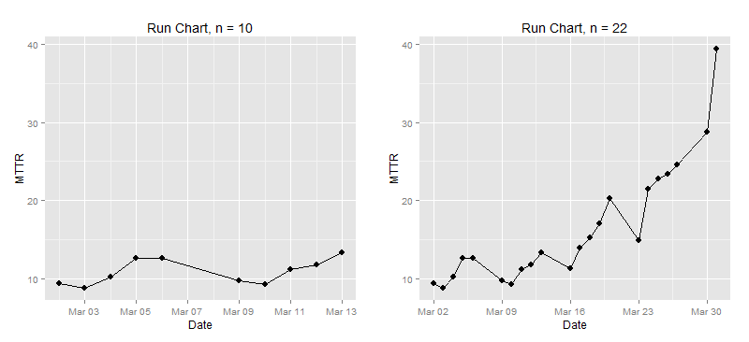
Exact Test  $$NM=\sum_{i=1}^{n-1}{{\left[rank\left(X_{i}\right)-\left(X_{i+1}\right)\right]}^{2}} \\ NM=82.5 \\ RVN= \frac{\sum_{i=1}^{n-1}{{\left[rank\left(X_{i}\right)-\left(X_{i+1}\right)\right]}^{2}}}{\sum_{i=1}^{n}{{\left[rank\left(X_{i}\right)-\frac{\left(n+1\right)}{2}\right]}^{2}}} \\ RVN=\frac{82.5}{\frac{10\left({10}^{2}-1\right)}{12}}= \frac{82.5}{82.5} \\ RVN=1$$  H_{O}: The sequence of MTTR is random  H_{A}: The sequence of MTTR follows a trend  $$NM = 82.5 ≤ {NM}_{α}=86$$  $$P\left[{NM}_{85}=0.0493 ≤{NM}_{α}=0.05 \right|{ H}_{O} is true]$$  Based on exact test, null hypothesis is rejected; there is significant trend.  R output  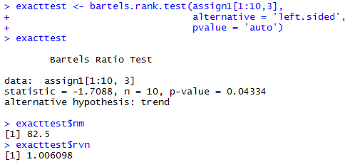 | Normal Approximation  $$NM=\sum_{i=1}^{n-1}{{\left[rank\left(X_{i}\right)-\left(X_{i+1}\right)\right]}^{2}} \\ NM=180.5 \\ RVN= \frac{\sum_{i=1}^{n-1}{{\left[rank\left(X_{i}\right)-\left(X_{i+1}\right)\right]}^{2}}}{\sum_{i=1}^{n}{{\left[rank\left(X_{i}\right)-\frac{\left(n+1\right)}{2}\right]}^{2}}} \\ RVN=\frac{180.5}{\frac{22\left({22}^{2}-1\right)}{12}}= \frac{180.5}{885.5} \\ RVN=0.2039 \\ E\left[RVN\right]=2 \\ Var= \frac{4\left(n-2\right)\left(5n^{2}-2n-9\right)}{{5n\left(n+1\right)\left(n-1\right)}^{2}} \\ Var=\frac{4\left(22-2\right)[5\left({22}^{2})-2(22)-9\right)}{{5\left(22\right)\left(22+1\right)\left(22-1\right)}^{2}} \\ Var=0.1698 \\ RVN \sim N\left(μ=2, σ^{2}=0.1698\right) \\ Z=\frac{0.2039-2}{\sqrt{0.1698}}= -4.360$$  H_{O}: The sequence of MTTR is random  H_{A}: The sequence of MTTR follows a trend  $$Z = -4.360 ≤ Z_{α}=-1.64$$  $$P\left[Z_{-4.360}<0.0005 ≤Z_{α}=0.05 \right|{ H}_{O} is true]$$  Based on normal approximation using asymptotic distribution, null hypothesis is rejected; there is significant trend.  R output  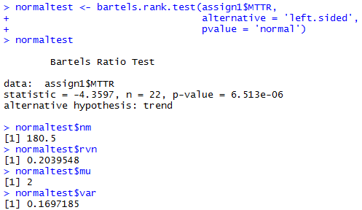

# Code block to install packages
is.installed <- function(x) {
is.element(x, installed.packages()[,1])
}

ifelse(!is.installed('randtests'), install.packages('randtests'), require(randtests))
ifelse(!is.installed('ggplot2'), install.packages('ggplot2'), require(ggplot2))
ifelse(!is.installed('gridExtra'), install.packages('gridExtra'), require(gridExtra))

url <- 'https://raw.githubusercontent.com/foxyreign/MasterOfStatistics/master/Stat%20266/Stat%20266%20-%20Assignment%201%20(Runs%20and%20Ups%20and%20Downs).csv'
download.file(url, "MTTR.csv")
assign1 <- read.csv('MTTR.csv', head = T, sep = ',')
assign1$Date <- as.Date(assign1$Date, format = '%Y-%m-%d')
assign1$Subset <- ifelse(assign1$Date < '2015-03-13', 'Exact Test', 'Normal Approx')
mttr.range <- range(assign1$MTTR)

# Normal approximation
bartels.rank.test(assign1$MTTR, alternative = 'left.sided', pvalue = 'normal')

# Use exact calculation or beta distribution
bartels.rank.test(assign1[1:10,3], alternative = 'left.sided', pvalue = 'auto')

# Plots the run charts, use fixed y
plot1 <- ggplot(assign1, aes(x = Date, y = MTTR)) +
geom_line() + geom_point(size = 3) +
theme_minimal() + ylim(mttr.range) +
ggtitle('Run Chart, n = 22')
plot2 <- ggplot(assign1[1:10,], aes(x = Date, y = MTTR)) +
geom_line() + geom_point(size = 3) +
theme_minimal() + ylim(mttr.range) +
ggtitle('Run Chart, n = 10')
grid.arrange(plot2, plot1, ncol = 2)

